**Dropping the Underground Network**

1. Drop all versions except sde.default.  
    as sde run “delete from sde.versions where name<>’DEFAULT’;”
2. Run a compress from ArcCatalog.
3. Ensure there are no connections to the database.
4. Open a command prompt, log into sqlplus as EDGIS, and run the ‘pm_order_number_idx_delete.sql’ script at the following location:  
   <http://edappgistfsprd1:8080/tfs/ElectricDistCollection/EDAMGIS/_versionControl#path=%24%2FEDAMGIS%2FSource_Development%2FDocumentation%2FData+Model%2FSchema%2FIndexes&_a=contents>
5. Connect to the database in ArcCatalog as business owner
6. Add the following buttons to the toolbar: Unregister as Versioned, Register as Versioned, Initialize Electric Trace Weights

Will look like:  

1. Export the connectivity rules via GDBDesigner or use a provided file from the DataModel Team.
2. Select the ElectricDataset
3. Unregister as Versioned.
4. Open the ElectricDataset and select the UndergroundNetwork
5. Delete it
6. Press “Initialize Electric Trace Weights” button : 
   1. If this step takes more than 30 minutes stop it. Normally that means the dataset was not unversioned.
7. Right click on the Dataset and select ‘New Geometric Network’
8. Name: UndergroundNetwork.
9. Leave the snapping set to **NO** (Unless this is an initial load of new data mostly used in conversion, never again!)
10. Select the feature classes you want in the network

|  |  |  |  |
| --- | --- | --- | --- |
| **Number** | **Feature Name** | **Role In Network** | **Source or Sink** |
| 1 | ConduitSystem | Simple Edge |  |
| 2 | SubsurfaceStructure | Simple Junction |  |

1. Press next

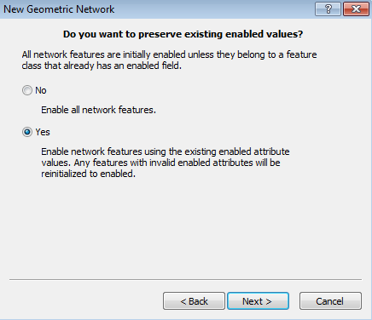

1. After all set hit next button.
2. There is no trace weight in this network.
3. Review the summary page and hit next
   1. The actual build of the network may take a long time. Please do not kill the ArcCatalog application, it is running, honest.
4. There are no connectivity rules for this network.

**NOTE:** If there is no other network to rebuild, continue here, otherwise do up to this point and come back to this document once all of them are to this point

1. Register as Versioned
2. Right click the ElectricDataset and select ‘Add GlobalIDs’. You do not need to repeat this step if you have already executed it for the ElectricDataset.
3. Select the electric dataset – right click and select ArcFM Solution Object Converter

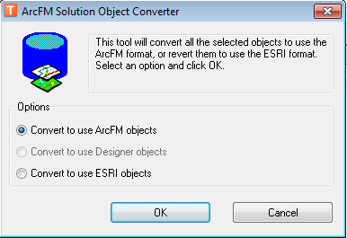

1. Run Trace all feeders, by right clicking on the network, if the data has been appended or changed in this process.

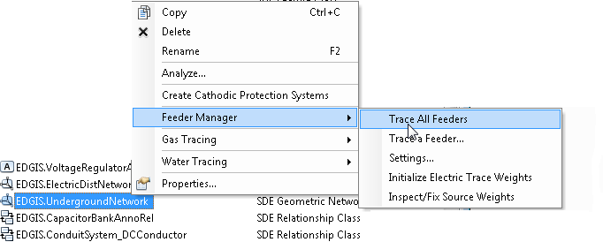

Notes:

1. All permissions must be reassigned because the data was versioned and unversioned.
2. Log into sqlplus as edgis and run the ‘pm_order_number_idx_create.sql’ script, located here:  
   <http://edappgistfsprd1:8080/tfs/ElectricDistCollection/EDAMGIS/_versionControl#path=%24%2FEDAMGIS%2FSource_Development%2FDocumentation%2FData+Model%2FSchema%2FIndexes&_a=contents>

**Change the ED0050 Config**

1. When rebuilding the geometric network the feature class ID for the default junction feature class will change. The ED050 configuration file must also change.
2. Open the Telvent.PGE.ED.Integration.DMS.Extractor.exe.config configuration file on the batch server that it runs on.
3. Via sqlplus run the following query to get the new feature class ID for the default junction.
   1. select objectid from sde.gdb_items where name = 'EDGIS.ElectricDistNetwork_Junctions';
4. Update the “FCIDMap” value to have “JU,####” where #### is the number identified by the query ran in step 3.
5. Save the configuration file.